

**Standardized Training for Personal Care Assistants for Agency-Based PCAs**

Community Options Unit

CT Home Care Program for Elders

CT Home Care Program for Disabled Adults

Acquired Brain Injury Waiver

**State Of Connecticut**

**Department of Social Services**

**Community Options Unit**

**55 Farmington Avenue**

**Hartford, CT 06105**

**Rev. 5/19 Version 2**

**STANDARDIZED CURRICULUM FOR PCA TRAINING**

**TABLE OF CONTENTS**

Introduction 2

Videos 3

Allied’s Role and Provider Audits 5

**Training Modules**

1. Universal Precautions 7
2. Communication Skills 9
3. Changes in Client’s Condition 13
4. Positioning 16
5. Lifting 17
6. Hoyer Lifts 19
7. Safe Transfers 22
8. Medication Policies 24
9. Emergency Procedures 26
10. Reporting Abuse, Neglect, Exploitation, Abandonment 28
11. Caregiver Boundaries 30
12. Acquired Brain Injury (ABI) 32
13. Bathing 36
14. Washing Hair 41
15. How To Wash Hair in Bed 43
16. Mouth Care 45
17. Dressing 47

**Introduction**

The purpose of this training is to ensure quality care for our clients, prevent critical incidents from occurring and provide a free tool for Connecticut Home Care Program agencies to assist with achieving this goal. Convenience, simplicity and a self-paced curriculum have been designed to support agencies’ efforts to train their staff.

**Guidance**

The training and certification test is required for agency-based PCAs. The training and certification test are paper-based. There is no online version. Agencies may use this training for other staff if they wish but it is not required.

* Existing PCAs have one (1) year to complete the training.
* New employees are required to complete the training within 90 days of hire.
* PCAs may pace their training as long as it is completed within one year.
* Completed quizzes should be placed in the employee’s personnel file.
* PCAs must take the certification test and pass with a score of 70.
* A Certificate of Completion is available at <https://portal.ct.gov/DSS/Health-And-Home-Care/Long-Term-Care/Community-Options/Documents>
* The Certificate should be placed in the employee’s personnel file. Allied Community Resources will be checking for completed quizzes and Certificates of Completion when they conduct audits.
* Certified Nursing Assistants and privately paid PCAs are **not** required to take the training; however, providers may use this training for any staff members.
* Allied Community Resources will be checking for evidence that training has taken place when they conduct provider audits. DSS receives Allied’s reports and will be notified if the training has not occurred.

Please refer to Provider Bulletin 18-37 “Required PCA Training” and the Important Message dated 7/13/18 Clarification of PB 18-37 “Required PCA Training” - Frequently Asked Questions on the [www.ctdssmap.com](http://www.ctdssmap.com) website.

**Videos**

**Changing Depends®**

[https://www..cyoutubeom/watch?v=Dg-TozzIKDQ](https://www.youtube.com/watch?v=Dg-TozzIKDQ)

**Positioning**

<https://www.youtube.com/watch?v=H68Sa04s_1s>

**Occupied Bed Making**

<https://www.youtube.com/watch?v=xyw1TN5BQQU>

**Fall with Assistance to the Floor**

<https://www.youtube.com/watch?v=QZxF6FectAQ>

<https://www.youtube.com/watch?v=HbldorHIhzI>

**Hoyer Lift**

<https://www.youtube.com/watch?v=drbOVe1A6ao>

**Safe Transfers**

<https://www.youtube.com/watch?v=oB0uPouIcXo>

<https://www.youtube.com/watch?v=fXXXUnpM-Ss>

**Smoking Hazards and Oxygen Tanks**

<https://www.youtube.com/watch?v=E-teitIZQsU>

<https://www.youtube.com/watch?v=2ARQkjVECio>

**Elder Abuse**

<https://www.youtube.com/watch?v=W9ikKP5-s5A>

<http://www.ctdss.net/learncenter/elderabuse/publ/>

**Caregiver Boundaries**

<https://www.youtube.com/watch?v=gJFNJvWYqCM>

<https://www.youtube.com/watch?v=L0PIwP4nSkw>

**Mouth Care**

<https://video.search.yahoo.com/yhs/search;_ylt=AwrDQqNGgtBc4TEAARQPxQt.;_ylu=X3oDMTByMjB0aG5zBGNvbG8DYmYxBHBvcwMxBHZ0aWQDBHNlYwNzYw--?p=videos+on+mouth+care+for+elders+adults&fr=yhs-pty-pty_email&hspart=pty&hsimp=yhs-pty_email#id=1&vid=6f707fc2b75d31775991c03cc1539c93&action=view>

**De-Escalation Tips**

<https://video.search.yahoo.com/yhs/search?fr=yhs-pty-pty_email&hsimp=yhs-pty_email&hspart=pty&p=video+on+de-escalation+techniques#id=6&vid=917f4a2abc8d39a2f3fbea79f1375171&action=view>

**Working with Clients with Dementia**

<https://www.youtube.com/watch?v=hgVMKEnkvHo>

**ALLIED’S ROLE**

Allied Community Resources conducts provider audits on behalf of the Department to determine if agencies:

* Maintain appropriate certification/licensure.
* Provide orientation, education and supervision to staff.
* Train PCAs and demonstrate evidence of this in employee personnel files.
* Maintain documentation including: tracking referrals from access agencies; responses to requests for and activation of services; activities related to provision of services; response, intervention and reporting on changes in the client situation or client plan of care.
* Fulfill reporting requirements.
* Maintain communication with the access agency charged with managing the client’s care.

**INTRODUCTION – PCA TRAINING MODULES**

**Personal Care Assistants**

What would our clients do without the PCA?  PCAs give so much of themselves each and every day. PCAs play a huge role in a client’s life.  Many times PCAs can be exhausted, frustrated, and overwhelmed, but that doesn't stop them from caring for their clients.  They trudge forward and do tasks that make their client’s lives better. PCAs are the eyes and ears on the client and perform a very important role in helping the client stay at home rather than going to a nursing home.

**The Basics**

**Client information, needs, care plan and required tasks**

The PCA supervisor informs the caregiver about:

* HIPAA
* Client’s care plan including client needs such as bathing, dressing, toileting, meal preparation, housekeeping, etc.
* Health care conditions that require attention
* The role of the care manager with care manager’s name and phone number
* Relatives, friends or others serving as back-up caregivers
* Client’s emergency contact person
* Doctor’s name, number in case of emergency
* Special needs such as dentures, hearing aid
* Name of pharmacy and phone number
* After hours emergency procedures
* Calling out sick procedures before and during shift
* Instructions on what to do if another caregiver does not show up for their shift, contacting the agency and ensuring coverage
* Policies on transporting clients

**1. UNIVERSAL PRECAUTIONS**

Follow safety techniques and good hygiene habits to stop the spread of germs and infections. To prevent the spread of infection and disease:

* Do not touch a person’s body fluids.
* Maintain a safe and clean work environment.
* Put waste in the right place.
* Use standard precautions and protective equipment to prevent spreading blood-borne pathogens (Germs spread from blood are called blood-borne pathogens).
* Wash hands frequently and correctly.
* Wear gloves, apron or mask as needed.

**Hand Washing**

Frequent hand washing is an easy way to avoid getting sick and spreading illness. Know when to wash your hands and how to wash the person. While you can never keep your hands germ free, you can limit the transfer of bacteria, viruses and other germs.

Wash your hands before:

* Eating
* Preparing food
* Providing personal care

Wash your hands after:

* Blowing your nose, coughing or sneezing into your hands
* Cleaning and disinfecting surfaces
* Contact with any bodily fluid (changing incontinent pads, using the bathroom)
* Direct contact with person for personal care
* Handling garbage or contaminated clothing
* Preparing food
* Removing gloves and other personal protective equipment

Use alcohol-based hand rubs if hand washing is not possible. Be aware that hand rubs are not effective against all germs so wash hands with soap and water as soon as possible.

**Protective Equipment**

The agency should provide all necessary protective equipment.

Use protective equipment when you are in a setting that may expose you to blood-borne pathogens. Protective equipment includes:

* Gloves.
* Containers for “sharps” which are items such as needles and razor blades. If there are no sharps containers in the home, find a safe place to discard them where there is no risk of needle sticks. The agency should tell you what to do and who to contact if you are stuck by a needle.
* Double-bags for waste. May use plastic laundry bags. Tape bags shut.
* Masks

**Blood-borne Pathogens**

A pathogen is something that causes disease. Blood borne pathogens are infectious diseases carried in the bloodstream. Blood borne pathogen infection may be caused by being stuck with a used needle or if bodily fluids touch a sore, broken skin or mucous membranes like the eyes, nose or mouth. The most common blood borne pathogens are hepatitis and HIV. If you believe you have been exposed, contact your supervisor immediately.

**Appropriate use of gloves**

Use gloves if you are likely to touch contaminated items. Some situations include when you:

* Change bandages or dressings
* Clean areas where body fluids have spilled
* Touch urine or stool
* Touch dirty items used in personal care
* Toileting
* Contaminated laundry
* Tissues with mucus, saliva

# Application and Removal of Gloves

* Wash hands.
* Apply clean gloves, do not reuse gloves**.** If gloves are not available in the home, contact your agency immediately.

To remove gloves after caring for the client:

* With right hand, grab opening of glove on left hand and pull glove over fist, removing the glove inside out. Discard glove.
* With left ungloved hand, grab glove on right hand near the opening and pull the glove over fist, removing the glove inside out. Discard glove.
* Always throw gloves away in a plastic garbage bag. An ungloved hand should never touch the outside of the contaminated glove.
* Wash your hands.

**2. COMMUNICATION SKILLS**

**Conversational Skills**

Getting to know clients and what makes the person happy helps to create a person-centered approach to caregiving. Familiarity with topics the person enjoys may help to calm or distract the person if he/she is resisting or refusing care at some point.

Helpful Topics:

* Family, friends
* Favorite foods
* Television shows
* Movies
* Books
* Music
* The past – childhood, school, jobs, pets

To communicate well, you need these skills:

* Make eye contact.
* Listening
* Ask good questions.
* Observe non-verbal communication. There are sometimes movements, gestures, facial expressions and even shifts in the client’s body that indicate something may be going on that they are not telling you.
* Speak openly and honestly to solve problems.
* Allow the client to express needs, wants or opinions without getting irritated, frustrated or angry.
* Speak to the other person with respect.
* Be respectful of the client’s race, ethnicity, religion, country of origin.
* Participate in activities like playing cards and games.

Dementia, Alzheimer’s disease, stroke, an acquired brain injury and other conditions may make communication more difficult. Don’t use too many words or long explanations because this may be confusing. Don’t give too many instructions or choices at once. You may not understand what the client is saying because they may be talking about things that happened in the past. Some clients may understand non-verbal gesturing better (like hand signals) if they are confused or hard of hearing.

**Alzheimer’s Disease and Dementia - Communication**

Communication requires patience and understanding. Alzheimer’s disease affects the whole brain. When the client is in the early stage, the ability to talk and be understood may only be slightly affected. The client may have a hard time thinking of words. Over time, difficulty thinking of the correct words will worsen as well as being able to understand what others are saying.

**Techniques to help:**

* Tell the person or show the person you’re trying your best to understand.
* Reassure the person and tell the person it is okay.
* Encourage the person to keep talking and don’t interrupt.
* Try to figure out what they’re trying to tell you by associating the words with their facial expression, the situation, their emotion and body language.
* If nothing makes sense, ask the person’s family or other supporters. Ask the family or others who know the person about the best way to communicate.

**Listening**

Listening is not just hearing, but doing your best to understand what the person means. Ways to be a good listener:

* Ask questions if you are not sure you understand.
* Be patient and let the client finish speaking.
* Give client your full attention.
* Pay attention to the client’s body language, such as facial expressions, tone of voice or body posture.

There are sometimes movements, gestures, facial expressions and even shifts in the client’s body that indicate something may be going on that they are not telling you.

**Aphasia** is a condition that affects the client’s ability to talk and communicate. It can affect the ability to speak, write and understand language, both verbal and written. **Aphasia** typically occurs after a stroke or a head injury. If the client has difficulty speaking, let the client write out what he/she wants to say. Some clients may use a communication board.

**Examples of Types of Communication Boards[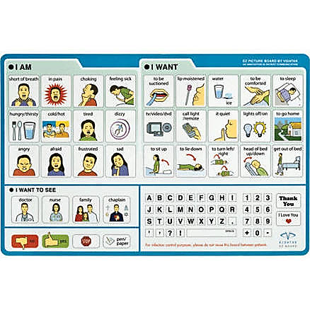](https://www.google.com/aclk?sa=l&ai=DChcSEwj9jvnCvPLTAhWXtsAKHQ7yDF4YABAQGgJpbQ&sig=AOD64_09gTMagMUqrf-jioDZEV4BOtuiBA&ctype=5&rct=j&q=&ved=0ahUKEwi99_XCvPLTAhUDxGMKHehsBlMQqCsIHg&adurl=)**

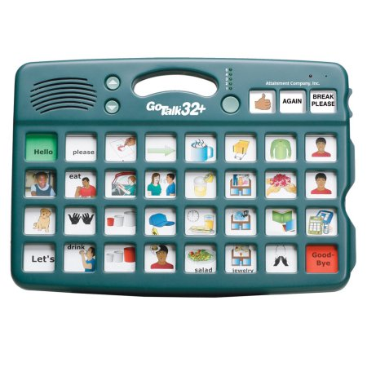

**3. CHANGES IN CLIENT’S CONDITION**

Because the caregiver spends a lot of time with the client, the caregiver acts as the eyes and ears on the client’s well-being. The client’s condition can change quickly and must be reported immediately.

Changes in a client’s condition should be reported immediately.

**Skin**

Skin care involves keeping the skin clean, preventing pressure on the skin for long periods of time, good nutrition and exercise if possible. It is important to regularly check the client’s skin for color changes, signs of soreness, breakdown and infection.

Skin care after toileting is very important. Urine and fecal matter can cause skin irritation and rashes. If a client is incontinent and uses Depends, skin care is very important. Pericare and rectal care should be done gently, from front to back, using gentle strokes rather than scrubbing. If there are areas that are very sore, squeeze water over it and pat dry.

Changing Depends® <https://www.youtube.com/watch?v=Dg-TozzIKDQ>

Check for:

* Red areas
* Bruises and Cuts
* Bed Sores
* Tears in the skin

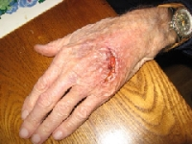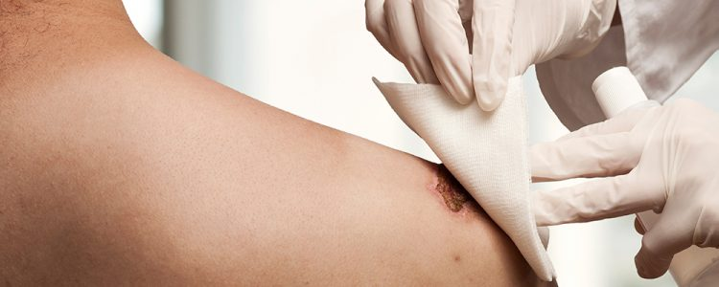

If the client has skin tears, do not grab the client’s arm. Skin can become very fragile and even the simplest bump can cause a tear.

Clients who cannot change position in bed or in a chair on their own must have the PCA change their position every two hours.

**How to Recognize Signs of Skin Damage**

* + - Red or pink areas on the skin that do not go away
    - Skin that appears shiny around the elbow
    - Blisters
    - Dark, discolored skin

Severe, untreated wounds may cause fatalities. Infections occurring due to severe wounds may cause death from deep tissue infection, bone infection, gangrene or blood infection. Spotting it early and getting help is extremely important. Clients who cannot get out of bed or a chair are at greater risk. PCAs are required to report sores and wounds to their supervisors. Wounds are easier to treat in early stages.

**Stage 1:** red area with pain, burning or itching.

**Stage 2:** swollen, painful, warm, and/or red; may ooze clear fluid or pus. Recovery time: 3 days to 3 weeks.

**Stage 3:** looks like a crater, may have a bad odor, with red edges, pus, heat, and/or drainage. The tissue in or around the sore is black if it has died. Recovery time: at least one month, and up to 4 months.

**Stage 4:** deep, big, black sore; shows signs of infection with red edges, pus, odor, heat, and/or drainage; may see tendons, muscles, and bone. These wounds need immediate attention. Recovery time: from 3 months or even years to heal.

**Appetite**

The PCA plays an important role in detecting changes in appetite, fluid intake and preventing possible complications. Good reporting can make a big difference in helping the client. Poor appetite is a common problem in older people. It can contribute to unhealthy weight loss, nutritional deficiencies and serious health problems. Loss of appetite may be due to poor fitting dentures making it difficult to chew. A gradual, slow decline in appetite and thirst may mean the client has a medical condition and should be reported. A sudden loss of appetite must be reported to your supervisor immediately. Also monitor how much the client drinks to avoid dehydration. If the client is having difficulty urinating, constipation or frequent diarrhea, report this to your supervisor.

**Behavior Changes**

Any gradual or sudden changes in a client’s behavior must be reported to your supervisor. If family members are involved in the client’s life, it is good to tell them, but you must also report it to your supervisor. Behavior changes may mean the client has a medical problem like a urinary tract infection or dehydration. Examples of behavior change:

* Becoming very tired and sleepy
* Sleeping for very long periods of time
* Dizziness
* Restlessness, pacing, repeating the same thing over and over, asking for a lot of attention, complaining and swearing
* Aggressive behavior, yelling, saying mean or hurtful things
* Doing strange things the client has not done before
* Self neglect, such as refusing to let you help with bathing, dressing; or refusing to eat
* Talking about deceased loved ones and wanting to join them, talking about wanting to die

**4. POSITIONING**

Positioning means placing the client in a good, comfortable position with legs and arms in a relaxed, easy position.

Why is Proper Positioning Important?

* To help the client to be comfortable
* To relieve pressure on various body parts
* To improve circulation
* To provide proper body alignment
* To prevent health problems caused by being in bed for long periods of time such as bed sores.

Procedures:

* Have any necessary assistive equipment ready.
* Get assistance, if necessary.
* Use good posture and position when lifting or positioning a client.
* Change the client’s position as needed or specified. Repositioning every 2
* hours is common practice. This is individual to each client and should be

specified. When you check a bedbound client for toileting, or a diaper change, the position should be changed at that time.

* Check the skin, on a regular basis, for signs of redness or irritation.
* Make sure the client is safe and comfortable.
* Report any changes to your supervisor.

**5. LIFTING**

* Do not lift anything that is too heavy for you.
* Use proper posture at all times. Maintain lower back in good alignment while standing or sitting. Proper posture decreases the chance of back injuries.
* Secure additional assistance if needed for safe moves.
* If lifting a heavy load, work with the force of gravity by pulling, pushing, rolling or lowering, rather than working against the force of gravity by lifting the load.
* Stand close to the object or client to be moved.
* Have feet at least 12 inches apart with one foot slightly in front of the other.
* Keep back straight, knees and hips flexed, weight distributed on both feet, and shoulders in line with pelvis.
* Use as many muscle groups as possible for moving the object or client. Leg and arm muscles reduce the workload on the back and support the load.
* When working at lower levels, do not stoop by bending over.
* To change the direction of the movement, pivot feet, with short steps, and the whole body without twisting the upper torso. To lower an object or client, always bend straight down toward the resting place; never twist to lower an object or client. Lowering straight down prevents twisting sprains and injuries to the back.
* Coordinate movements with the client or the staff member assisting with moving the client or object.

When lifting a heavy object or client:

* Squat
* Stand to lift
* Carry object or client close to body
* Carry using muscles that pull shoulder blades together. Lifting in this

manner lessens back strain.

[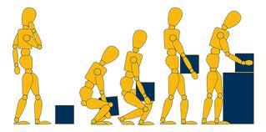](http://www.google.com/url?sa=i&rct=j&q=&esrc=s&source=images&cd=&cad=rja&uact=8&ved=0ahUKEwi1uLuZgazTAhVo2IMKHXiRCioQjRwIBw&url=http://www.yoursafetyworks.co.uk/News/News13-03.html&psig=AFQjCNFG_D-ydX1UmwH-mZiCp0JKDQ7XMQ&ust=1492536202057034)

**6. HOYER LIFT**

**The PCA must be trained to use any equipment. The Supervisor needs to make sure the PCA uses the equipment correctly. Check with your agency on Hoyer lift policy.**

The care manager may order a Physical Therapy evaluation. The Physical Therapist will teach the PCA how to use the equipment.

The Boom of the lift does not swivel. Center the client's weight over the base legs at all times. Do not attempt to lift consumer with the mast/boom assembly swiveled to either side. Always keep the client facing the attendant operating the lifter.

**Transfer from Bed**

If the client is in a hospital bed, raise side rails and have the client hold onto rails. Raise the level of the bed to the highest position before moving the client onto the sling. This will reduce strain on the caregiver's back. Also, when the client is ready to be lifted, lower the side rail and the level of the bed, decreasing the distance the client has to be elevated.

Positioning the lift for use:

* With the legs of the base open and locked, use the steering handle to push the lift into position.
* Lower the lift for easy attachment of the sling.



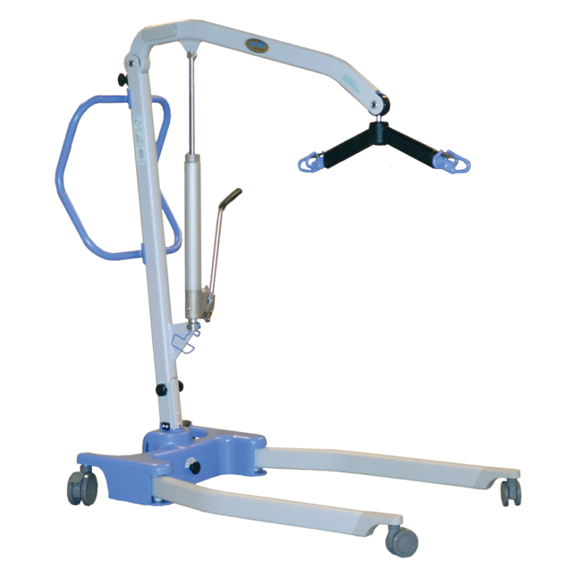

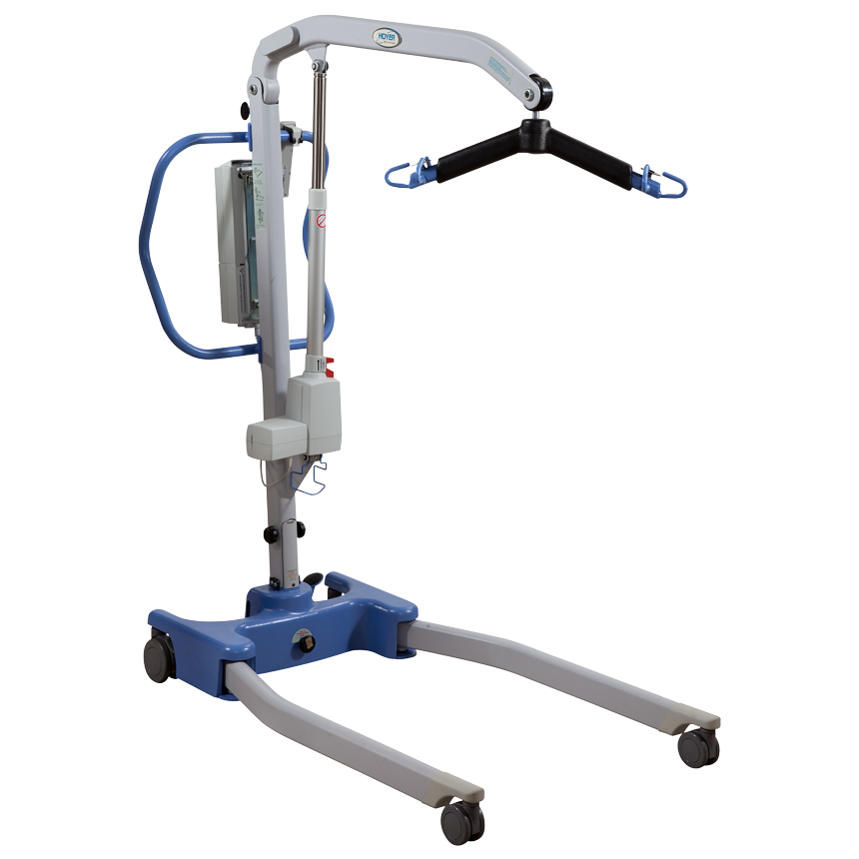

**7. SAFE TRANSFERS**

* Bed to chair and return - If this is a pivot transfer, the PCA must ensure the chair is positioned close to the bed. The client should have secure fitting shoes or slippers on for transfers. The PCA will position himself/herself in front of the client, place his/her feet against the toes of the client, put his/her arms under the clients arms, place one knee in front of the client’s knee and stand straight up, holding on to the client

at all times.

* Bed to wheelchair and return - The PCA must ensure the wheelchair is in the correct position with the wheels locked in place. Make sure the wheelchair is positioned so the client’s feet will not become entangled in the footrests. If footrests are movable, fold the person up and out of the way.
* Bed to toilet/commode and return - The PCA should ensure the bedside commode is properly positioned beside the bed to allow the client to transfer with minimal exertion.
* Bed to tub/shower and return – The PCA should ensure the client is wearing secure fitting shoes or slippers. Assist the client to a sitting position on the side of the bed. Assist the client as needed to a standing position; offer stand-by assistance to the bathroom.
* Chair to commode and return - Ensure the client is wearing secure fitting shoes or slippers. Assist the client to a standing position; provide stand-by assistance to the bathroom.
* Chair to tub and return - Ensure the client is wearing secure fitting shoes or slippers. Assist the client to a standing position. Provide stand-by assistance to the bathroom. Assist the client to disrobe and stepping into the tub.
* Wheelchair to tub and return - Ensure the client is wearing secure fitting shoes or slippers. Roll the wheelchair into the bathroom and lock the wheels. Assist the client to a standing position. Assist the client in disrobing, and stepping into the tub.
* Wheelchair to commode and return - Ensure the client is wearing secure fitting shoes or slippers. Roll the wheelchair into the bathroom and lock the wheels. Assist the client to a standing position. Assist the client in pulling down his/her underpants, and help him/her to sit safely on the commode.

**8. MEDICATION POLICIES**

PCAs may assist with self-administered medication: Medication taken by mouth, injection, nebulizer or insertion, or applied topically without the need for assistance. Means the client directly swallows, applies, inhales, inserts, or injects a medication into his or her own body.

A personal care assistant (PCA) may assist with medication.

Assisting includes:

* Reminding the client when to take the medication
* Reading the prescription label for the client
* Bringing the medication and any necessary supplies or equipment to the client
* Opening the pill bottle or container
* Positioning the client in a good position to take the medication
* Providing water or other liquid for swallowing medication
* Storing, cleaning and disposal of used supplies and equipment
* Putting away and storing medication properly

Once the task to supervise self-administration of medication is delegated to the PCA, a supervisor or family member should train the PCA specific to the task.

A PCA must follow the care plan and be directed by either the client who can direct their own care or a responsible party. A responsible party does not have to be present when the PCA assists with taking medication. However, the responsible party must assure the medication is set up as individual doses and labeled with:

* Name and dosage of the medication
* Time the medication is to be given
* Method to assist the person to take the medication

For medications given on an as needed basis the client must self-direct the PCA or the PCA must notify the responsible party before assisting with the medication.

**PCAs do not:**

* Determine the dose or what time the medication should be given.
* Decide if the client needs medication or decide if the medication is working or not.
* Inject fluids and medications into veins, muscles, or skin.
* Cannot crush medicine and put it in applesauce, or pudding, or similar substance.
* Put medication in the person’s mouth.
* Insert vaginal or rectal suppositories.
* Apply prescription or non-prescription cream or ointment to a wound or a sore.
* Cannot EVER pre-fill medication boxes

If you drop a medication, or the med box, if the pills do not appear to be correct, do not administer the pills, call your supervisor.

If family members are telling you or trying to convince you to administer medication, contact your supervisor. PCAs cannot administer medication.

**9. EMERGENCY PROCEDURES**

All emergencies should be immediately reported to your supervisor.

**DO NOT TRANSPORT THE CLIENT TO THE EMERGENCY ROOM**

**DO NOT GO TO THE EMERGENCY ROOM WITH THE CLIENT UNLESS THE CLIENT HAS DEMENTIA, ALZHEIMER’S DISEASE OR IS UNABLE TO SPEAK. NOTIFY YOUR SUPERVISOR BEFORE YOU GO. LEAVE AFTER THE CLIENT IS TAKEN TO A ROOM.**

**When to call 911**

* Medical Emergencies
* Bleeding
* Heart Attacks
* Strokes
* Choking
* Shock
* Burns
* Falls
* Broken bones

**Falls**

If the client falls, call 911 for help. Help the client find a comfortable position until help arrives. Falls must be reported to your supervisor.

**Fall Prevention**

Home can be a hazardous place for seniors. Everyday objects and decorative items can create fall hazards and pose dangers. Falls are the leading cause of fatal injury among older adults. If these hazards are present in the home, the PCA can be observant to help prevent a fall.

Below are some common hazards:

* Throw rugs: Throw rugs move and the edges can flip up while the client is walking.
* Piles of clutter: Piles on the floor can easily be tripped over.
* Poor lighting: Stairs, walkways and hallways that are not well lit create a significant fall hazard. Clients often have problems with vision and need bright lighting to notice changes in walking surfaces.

**[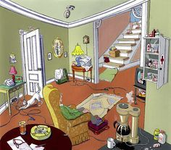](http://mobility123.com/fall-prevention-spot-the-dangers/)**

* Remove furniture or other things in the way to create a clear path so the client may avoid bumps or falls.
* Assist clients with sitting and standing if they are likely to fall.
* Encourage the client to use their cane or walker.
* Encourage the client to use handrails if they are available.
* Make sure the client is wearing shoes or non-slip footwear.

|  |  |
| --- | --- |
| |  | | --- | |  | |

**Fire Safety**

Be aware of the client’s ability to exit the home in the event of a fire and accessible exits. Make sure you remember the client’s street address.

**Oxygen**

* There should be no smoking, open flame or heat source close to the oxygen. This will increase the risk of a fire.
* Keep oxygen away from heaters, radiators, and hot sun.
* Never let oil, grease, or highly flammable material to touch or get on oxygen cylinders.
* Do not use aerosol cans like hair spray or air fresheners near oxygen.
* Never put anything over an oxygen gas tank.

Immediately report to your supervisor if the client is smoking around the oxygen. Smoking near oxygen places both the client and the caregiver in danger.

**10. REPORTING ABUSE, NEGLECT, EXPLOITATION, ABANDONMENT**

## Toll-Free Elder Abuse Referral Line In State: 1-888-385-4225 After Hours Elder Abuse Emergencies In State: Call Infoline at 211

As a PCA you and your agency are mandated reporters of any abuse, neglect by another person, self neglect or exploitation you observe toward your client. A mandated reporter is a person who is required to make a report if there is a reason to believe that the client has been a victim of abuse, neglect, exploitation or abandonment. You must contact your supervisor immediately if you observe the client being mistreated by another caregiver, family member, friend or other person. Contact your supervisor if you suspect abuse, neglect, self neglect, exploitation or abandonment.

Abuse is when another person injures, intimidates or punishes the client resulting in physical harm, pain or mental anguish. Abuse can include sexual assault, physical assault and verbal abuse. The client should never be restrained or confined to a chair, room or other location.

Neglect means that care is not being given by family or others who are supposed to care for the client when other help is not in the home. It can mean that the client refuses necessary services which may create a risk to the client’s health or safety. You should report any home environment without heat, hot water, electricity and situations that may create a threat to life, health or safety such as lack of repairs, unsanitary or toxic conditions.

Self-neglect is when an individual neglects to take care of their [basic needs](https://en.wikipedia.org/wiki/Basic_needs), such as bathing, dressing, wearing clean clothing, eating, drinking, not going to the doctor when she/he is sick or not taking medications.

Exploitation is taking a client’s property without permission, the deliberate misplacement of client’s property or use of a client’s belongings or money without the client’s consent; deliberate damage, destruction, theft, misplacement or use of a client’s belongings or money without the client’s consent, including taking the client’s medications. The client’s money must be used on items the client needs such as food or medication.

Abandonment refers to a caregiver leaving an elderly person alone during a working shift or if the next caregiver does not show up for their shift and/or failing to perform personal care attendant duties.

If you become aware of any of these situations, you must report it immediately to your supervisor.

**11. CAREGIVER BOUNDARIES**

Boundaries are guidelines, or limits, that a personal care assistant sets with the client regarding acceptable behaviors or tasks. It includes both the personal care assistant and the client understanding the expectations.

Clear limits promote safe connections between caregivers and clients; being friendly, not friends.

**Types of Boundaries**

* Role Boundaries
  + The PCA is in the client’s home as an employee.
* Social Boundaries
  + Talking to and spending time with the client only occur during work hours.
* Time Boundaries
  + PCAs arrive on time for their shift and leave at the scheduled time.
* Gift/Services
  + The caregiver/client relationship should not include giving each other gifts or other services outside of the caregiving role.
* Self-Disclosure
  + PCAs should use caution when sharing personal information with the client. Some information may be upsetting to the client.
* Financial Boundaries
  + The PCA’s duties do not include financial responsibilities. To avoid misunderstandings, exactly who will pay and how needed items will be paid for should be clear from the beginning. If family members are involved, they should be buying food and other items the client needs. The PCA should report it to the supervisor if asked to budget, pay bills or similar tasks.
* Social Media and Confidentiality
  + Do not friend your clients or accept friend requests from your clients on Facebook.
  + You should never post pictures or videos of your client or their family members.
  + Do not post negative comments or gossip about your clients.
  + Do not post information about where your client lives, who their friends or relatives are or where they are. Posting this kind of information is a serious violation of client confidentiality.

**Poor Boundaries and Crossing Boundaries**

The following actions and behaviors must not happen between the caregiver and the client:

* Relatives or friends should not drive you to the client’s house. The client’s address and phone number should not be given out to anyone. This violates the client’s privacy.
* Relatives and friends should not deliver food to the client’s home or enter the client’s home. This is also a violation of privacy.
* Nicknames: calling a client “sweetie” or “honey”
* Too much touching. Touching should only occur during caregiving duties such as bathing and dressing.
* Do not tell jokes that could be offensive, make comments about a client’s race, ethnicity, religion or politics. Caregivers’ opinions on religion, politics or sensitive subjects should be kept to themselves regardless of whether they agree or disagree with the client.
* Do not use profane or vulgar language.
* Do not loan or borrow money.
* Do not encourage the client to give you gifts. Do not accept any expensive gifts. Do not give gifts to the client.
* Do not use the client’s money, debit cards, credit cards, EBT cards without the client’s permission. If the client gives permission to use these items, the caregiver must obtain a receipt and give it to the client.
* Romantic Relationships: A caregiver is never permitted to have a

romantic or sexual relationship with a client.

**12. WORKING WITH CLIENTS WITH ACQUIRED BRAIN INJURY**

*(you may skip this section if you do not work with clients with acquired brain injury)*

Acquired brain injury is any type of brain injury that happens after birth.

When the head is struck hard, the brain slams against the inside of the skull, causing physical injuries such as bruising, swelling or bleeding. The person with an ABI may have a variety of physical and emotional symptoms.

Causes of traumatic brain injury include:

* Car accidents
* Blows to the head
* Sports injuries
* Falls or accidents
* Physical violence

Acquired brain injury may result in problems such as:

* Memory
* Learning
* Reasoning
* Judgment
* Attention or concentration
* Problem-solving
* Organization
* Planning
* Decision-making
* Beginning or completing tasks

Communication problems may include:

* Difficulty understanding speech or writing
* Difficulty speaking or writing
* Inability to organize thoughts when trying to speak
* Trouble participating in conversations, starting or stopping conversations

Changes in behavior may include:

* Difficulty with self-control
* Lack of awareness of abilities
* Risky behavior
* Difficulty in social situations
* Verbal or physical outbursts

Emotional changes may include:

* Depression
* Anxiety
* Mood swings
* Irritability
* Anger

Some clients may:

* Be unable to say what they want.
* Be unable to explain something.
* Be unable to understand others.
* Feel frustrated and aggravated.

**What You Should Know**

* Some clients may have trouble concentrating or organizing their thoughts. If you are in a public area with many distractions, consider moving to a quiet or private location.
* Some clients may have a hard time understanding what you say so you may have to repeat it. If you are not sure whether the client understands you, offer assistance with what the client is trying to do. The client may need extra time.
* Be patient, flexible and supportive.
* Be patient if the client repeats his or her stories and experiences, and avoid interrupting the person.
* A client may have trouble remembering things and learning new things

Behavioral problems are common following acquired brain injury. Many people with brain injury experience changes in behavior, personality and mood.

**How to Handle Angry and Aggressive Behavior**

**Acquired Brain Injury**

Individuals may become angry, hostile or violent. Do not argue. Staying calm is very important. Use a gentle, soft voice, speaking slowly and confidently and avoid raising your voice or talking too fast.

* Speak to the person in a calm, soft voice in an attempt to calm the person down.
* Do not stand close to the client. Avoid arm and hand movements.
* Attempt to distract the person, change the subject and re-direct his attention to something else.
* Do not restrict the person’s movement. If he/she wants to stand, allow it. Do not corner the person.
* Do not touch the person or make sudden moves.
* Do not threaten the person. Threatening could increase the person’s fear, which could cause aggression.
* Show an interest in resolving the issue and meeting the client’s needs and concerns.
* Avoid having too much noise, such as loud music, television, loud conversation

**Contact your supervisor immediately if you believe that you may be physically harmed if the situation gets worse. Call 911 if you are in danger.**

**Persons with Alzheimer’s Disease or Dementia - Causes of Agitation and Aggression**

Most of the time individuals get angry and aggressive for a reason. Try to find the cause. If you figure out why the individual is angry or agitated, you may be able to calm the person down.

Possible reasons for anger or aggression:

* Pain, depression, or stress
* Too little rest or sleep
* Constipation
* Soiled underwear or Depends®
* Sudden change in a well-known place, routine, or person
* A feeling of loss—for example, the person may miss the freedom to drive, friends, activities
* Too much noise or confusion or too many people in the room
* Being pushed by others to do something—for example, to bathe or to remember events or people—when Alzheimer’s has made the activity very hard or impossible
* Feeling lonely and not having enough contact with other people

Look for early signs of agitation or aggression. Try to figure out what is causing it. Don’t ignore the problem because if you don’t try to help, it can make things worse.

**13. BATHING**

**Safety**

The bathroom is one of the most dangerous places in the home, especially for older adults. Each year numerous individuals slip or fall causing serious injuries. Older adults are at greater risk of injury because some medications they take can cause dizziness or low blood pressure and they may have difficulty standing or walking. Surfaces in the bathroom (metal, cold tile and porcelain) are slippery when wet and have no cushion when a person falls.

If the person does not have the right equipment to give a safe shower, ask your supervisor to contact the care manager to request a physical therapy evaluation.

**General Tips for Bathing**

* Encourage the person to bathe herself/himself as much as possible.
* If bathing is difficult, do it only as often as in the plan of care.
* Make sure that the hands, face, and genital area are washed every day.
* Have all supplies ready before starting a bath. Keep the room comfortably warm.
* Respect the person’s privacy. Keep her/him covered when possible.
* Wear gloves.

Safety is important when giving a shower. If a shower chair is used, check it to make sure it’s sturdy. Adjust the height as needed. Put a bath mat or towel on the floor outside of the shower to prevent the person from slipping on a wet floor when she/he steps out of the shower.

**Always stay with the person while she/he is in the shower.**

If the person becomes dizzy during a shower, turn off the water. If the person is standing, have her/him sit down and lower the head as much as possible. Cover the person with a dry bath towel.

During the shower, look at the person’s skin for areas of redness, rashes, rough areas or tenderness. Look at the person’s feet to see if there are any sores, blisters or redness. Report this information to your supervisor.

**Procedures for a Shower:**

1. Get everything you will need.

2. Make sure that the bathroom is warm.

3. Make sure the shower chair is clean. Clean the chair if necessary.

4. Place a nonskid mat in shower stall if the person is standing during shower.

5. Explain what you are going to do. This is very important for persons with dementia.

6. Wash your hands and put on gloves.

7. Ask the person if she/he needs to go to the bathroom. It may be easier to undress the person on the toilet.

8. If the person wants to undress in her/his room, assist the person to undress and put on robe and slippers.

9. If the person cannot walk, take the person by wheelchair to the bathroom.

10. Transfer the person to the shower chair.

11. Turn on the shower and adjust water temperature. Direct water spray away from the person while adjusting. Flow rate should be gentle. Check water temperature on an inner surface of your forearm. NEVER have a person step into a shower before the water temperature has been tested.

12. Help the person to wash as needed. If the person can’t help, start with the eyes then wash face, ears, neck, arms, hands, chest, abdomen, and back. Ask the person if she/he wants soap used on the face.

13. Rinse with warm water.

14. Wash legs, feet, genital area and in between toes. Wash genital area from front to back. NOTE: Wash female genital area from front of chair; wash anal area from under the chair. Rinse well with warm water; discard washcloth in a laundry basket.

15. Turn off shower and cover the person with a towel; place towel around hair if wet.

16. Assist the person out of shower.

17. Remove and dispose of gloves.

18. Uncover the person one area at a time and pat dry. CAUTION: Once a towel has been used to dry any area below the waist, it should not be used on other areas.

19. Apply non-talcum powder, lotion, and deodorant if the person wants the person. During the entire process, check the skin for breakdown, unusual bruising, cuts, or anything unusual.

20. Assist with dressing.

21. Help the person to a comfortable place and assist with any personal care such as shaving and hair care.

22. Do not cut fingernails or toe nails. If the nails are a problem, report it to your supervisor.

23. Return to bathroom, remove soiled articles, and clean the shower chair.

24. Wash your hands.

25. Report anything unusual to your supervisor.

**Bathing Persons with Dementia, Alzheimer’s disease or Cognitive Deficits**

Bathing may be difficult when bathing persons with Alzheimer’s disease, dementia, or other cognitive impairments. Cognitive impairment is when a person has trouble remembering, learning new things, concentrating, or making decisions that affect their everyday life. Some persons may refuse to bathe. If the person continues to refuse, it is probably because the person is afraid of something about taking a bath or shower. Individuals with dementia, Alzheimer’s disease and cognitive impairment may not be able to tell you what is bothering them.

**Tips:**

**Daily routine**

Establish a regular daily schedule that includes bathing at the same time every day. It becomes a normal part of their day, like eating or sleeping. A predictable daily routine reduces stress and anxiety.

**Comfortable and Warm Bathroom**

Many older adults don’t like bathing because they are afraid of being cold. Older adults feel cold more easily than a younger person.

**Avoid Arguments**

Don’t argue about bathing. Keep sentences short and simple. Make eye contact, and smile. Extend your hand so they’ll take it, get up, and let you escort the person toward the bathroom. Talk about something positive or rewarding to change the focus. Ask about their favorite things like music, TV shows and movies. Ask the person about their children or grandchildren. Find out what makes the person happy. Have this conversation in advance to be prepared with positive topics. Do this often so that when the person takes a shower, they think of positive things that they enjoy.

**Calming**

It is best if the atmosphere is calm. Use calm, soothing tone of voice, or play soothing music they like. When the water is warm, slowly spray water on body parts to give the person time to adjust to the feeling.

**No Surprises**

There are many steps to bathing which may be upsetting to someone with dementia, Alzheimer’s’ Disease or cognitive disability. Let the person know what’s going to happen and talk the person through it to avoid fear or anxiety.

If the person really does not want to bathe or shower, do not force the person. Wait for several hours or the next day. Report this to your supervisor.

If the person is incontinent, try to wash the urine or feces from the area. Explain that you’re doing it so the area won’t be sore and painful.

**How to Give a Bed Bath**

**Supplies**

* Water basin and washcloths
* Bath towels
* Soap, lotion, and deodorant
* Lightweight blanket
* Clean clothes

**Preparation**

* Close the windows and turn up the heat to keep the room warm.
* Fill the water basin with warm water and check the water temperature.
* Place towels under the person to keep the bed dry.
* Cover the person with a blanket or towel. Use the blanket or towel to keep the person warm.

**Process**

* Make sure the person cannot fall out of bed.
* With soap and water, wash and dry the face, neck, and ears.
* Wash one side of the body from top to bottom and repeat on the other side. Start by washing the shoulder, upper body, arm, and hand then the hip, legs, and feet. Rinse the soap off of each area and pat dry. Check for redness and sores during the bed bath.
* The genital area is the last area to be washed. For women, wash the genital area from front to back. For men, make sure you wash around the testicles. Roll the person to the side to clean the buttocks.
* Apply lotion to the arms, legs, feet, or other dry skin areas.
* Remove all dirty washcloths and towels and help the person dress.
* Clean the water basin.
* Report any skin changes, like redness, to your supervisor.

**14. WASHING HAIR**

If the person is able to wash his/her own hair, it is okay if the person would like to do it for himself/herself.

**How often to wash**

Ask the person if they would like to wash their hair. Pay attention to the how the hair looks, how it smells, and if it seems dirty. If you see redness, a lot of dandruff or have concerns about lice, report this to your supervisor.

If the person does not like having the hair washed, once every week or every two weeks is okay. Brush or comb the hair daily.

Dry shampoo can be used in between.

**Sitting the Bathtub**

Have plenty of clean, dry towels available. Use a cup or shower hose to direct the water away from the face. Many people do not like water in the face. Water in the face may be more upsetting for anyone who is not healthy, has dementia, Alzheimer's disease or a cognitive deficit. Make sure you test the water temperature first and rinse the hair. Shampoo the hair and rinse. Dry the hair with the towels. Comb or brush the hair.

**Standing in the shower**

If the person you're caring for is able to stand in the shower, make sure the person is steady and is able to stand long enough to shampoo the hair. The person needs good balance to do this. If the person is not steady, offer to help and make sure a tub chair or a shower chair is available. Do not leave the person alone.

**Sitting at the sink**

If the person does not want to have her/his hair washed in the tub or shower, you can ask if the bathroom or kitchen sink would be okay. Bring the supplies to the sink. You should have either a kitchen hose or a cup. You will need shampoo and plenty of towels.

The person can either face toward the sink and lean the head forward over the sink or sit facing away from the sink and lean the head back over the sink. Leaning back is the best way to keep water out of the person’s face. Make sure you test the water for temperature. Rinse the hair with a cup of water or a small sink hose, shampoo and rinse. Cushion the neck well with towels. Dry the hair well with towels to prevent a lot of water dripping on the floor. Comb or brush the hair. Wipe up water that has dripped on the floor.

**15. HOW TO WASH HAIR IN BED**

Before you get started, make sure you have all the supplies you need.

**Supplies**

* Garbage bags or other waterproof cover and towels to line the bed and keep it dry
* Washcloth
* Towels
* Shampoo
* Basin of warm water
* Cup or pitcher for pouring water
* Bucket, large bowl or pot to drain dirty water
* 🞶🞶🞶 Inflatable Hair Wash Basins/Portable Shampoo Tray (if available, see pictures below)

**Washing the hair**

* Make sure the area around the bed is clear and the room temperature is warm.
* Wash your hands and put on gloves.
* Remove the pillows from under the person’s head.
* If possible, elevate the head and put something under the head to collect the water. See examples below. Use one of those devices if they have one.
* Place a plastic sheet or garbage bag under the person’s head and put towels around the person’s shoulders. The edge of the trash bag should drip into the bucket or bowl.
* Explain what you are going to do.
* Fold the sheet, blanket and bedspread down to the waist.
* Cover the upper part of the body with a towel.
* Put a bucket, large pot or large bowl on the floor to catch the running water and put a sheet or towel underneath.
* Put the clean water basin next to the bed.
* Gently lift the person’s head and place a towel underneath the patient’s neck.
* Fill the basin with warm water. Check the temperature of the water.
* For short hair, you can rub a wet washcloth over the head until the hair is thoroughly wet. For longer hair, fill a cup or pitcher with water from the basin, carefully wet the person’s hair and make sure the water drains into the bucket/bowl or pot.
* Put a washcloth over the person’s eyes.
* Shampoo the person’s hair using a small amount of shampoo.
* Rinse the hair thoroughly. Start at the top of the head and go down to the bottom of the head.
* Squeeze excess water from the hair into the bucket/bowl or pot.
* Gently rub hair dry with a towel. Dry the person’s face.
* Comb or brush the person’s hair.
* Change the sheets if they are wet and clothes if they are wet.
* Pour the water down the sink or tub.
* Put the supplies away.
* Remove your gloves.

**Examples of Inflatable Hair Wash Basins/Portable Shampoo Trays**

**For Bed Bound Clients**

These may not be available.

[](https://www.google.com/aclk?sa=l&ai=DChcSEwjP9-m52L_bAhUDHoYKHZ_OB4QYABAZGgJ2dQ&sig=AOD64_3v7ju5arNDnM3pwO_LgAEhbwcstQ&ctype=5&rct=j&q=&ved=0ahUKEwiBk-a52L_bAhWvslkKHWvbC2cQwg8IZQ&adurl=)[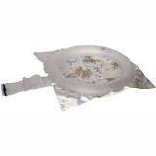](https://www.google.com/aclk?sa=l&ai=DChcSEwj8nOGn2b_bAhWMWYYKHXDLB2cYABAfGgJ2dQ&sig=AOD64_0J2GuiiRoV2Sl6wGZKbteqXueNmQ&ctype=5&rct=j&q=&ved=0ahUKEwjw392n2b_bAhXxqFkKHR8lDbkQwg8IcQ&adurl=)[](https://www.google.com/aclk?sa=l&ai=DChcSEwj8nOGn2b_bAhWMWYYKHXDLB2cYABAXGgJ2dQ&sig=AOD64_1s91e6zrm_Z0Age2WDe-QOmyhmwA&ctype=5&rct=j&q=&ved=0ahUKEwjw392n2b_bAhXxqFkKHR8lDbkQwg8IYQ&adurl=)[](https://www.google.com/aclk?sa=l&ai=DChcSEwj8nOGn2b_bAhWMWYYKHXDLB2cYABA1GgJ2dQ&sig=AOD64_3ZdKl54MzJq1wAvXnYX85BU_V-dA&ctype=5&rct=j&q=&ved=0ahUKEwjw392n2b_bAhXxqFkKHR8lDbkQwg8InQE&adurl=)

**16. MOUTH CARE**

Good mouth care is very important to prevent cavities, bleeding gums, gum infections and pain. A healthy mouth is important for general health. Healthy teeth and gums allow people to eat, speak and socialize without being embarrassed. Toothaches and gum infections can make it even harder to function for elderly people, people with dementia or cognitive impairment. Mouth and gum infections can lead to other health problems like heart disease, stroke and pneumonia.

**Brushing Teeth**

* Wash your hands and put on gloves.
* Set up the supplies such as the toothbrush, mouth swabs, mouthwash, cup or bowl or basin.
* Place supplies on the sink. If the person cannot brush at the sink, place a bowl or basin on a tray with paper towels under the bowl or basin. If there is no tray, use the kitchen table or other safe surface.
* Wash the toothbrush in the sink. Put a small amount of toothpaste on the brush.
* Brush the teeth softly. Brush the outside of the teeth, then the inside of the teeth.
* Softly brush the upper teeth by brushing at the top of the gums and moving downward. The reason for this is because it moves the plaque away from the gums. For lower teeth, brush upward away from the gums.
* Lightly brush the tongue.
* After you are finished brushing, have the person rinse with water and spit into the sink or the bowl or basin.
* After you are done, rinse out the toothbrush and put away the supplies.
* Remove the gloves and wash your hands.

**Dentures**

* Wash your hands and put on gloves.
* **Put dentures in a water-filled container.**
* Brush dentures thoroughly.
* Ask the person to rinse mouth with an alcohol-free mouthwash if they want to.
* Put the dentures in the person’s mouth.
* Rinse out the denture container.
* If the person does not want to wear the dentures, put the dentures in the denture container with water.
* Remove gloves and wash your hands.

If you see any redness, bleeding or sores, report this to your supervisor.

**Mouth Care for Persons with Dementia, Alzheimer’s Disease or Cognitive Impairment**

* Slowly walk toward the person, smile and look into the person’s eyes.
* Tell the person what you are going to do and why you’re doing it.
* Speak slowly and clearly. Be patient and repeat what you said if necessary.
* Ask the person if it’s okay before starting.
* Be positive and encouraging.
* Only do as much as you can do if the person becomes upset.

**Person Refuses Mouth Care**

* Try to find out why the person does not want mouth care like being afraid or mouth pain.
* If the mouth is painful, look for broken teeth, redness or sores in the mouth. Tell your supervisor if you see this.
* If the person is afraid, play music the person enjoys, say things that are calming.
* Try talking about something the person enjoys, the weather or other positive topic.
* Try to do mouth care around the same time every day.
* Tell the person all of the good things about mouth care like getting the food out of the teeth, their mouth will feel better, their smile will be brighter.
* If the person refuses, try again at another time.

**17. DRESSING**

* Before you assist with dressing, wash your hands carefully to avoid spreading germs.
* Make sure that a clean set of clothes is ready to wear.
* Greet the person and explain that you want to help the person get dressed or change clothes.
* The person may need you to dress her/him completely. If possible, you can help the person to dress herself/himself.
* Remember not to pull, push or handle the person roughly.
* Assist the person to remove clothes if needed. Let the person do as much as possible without your help.
* Put the clean clothes in a place they can be reached easily.
* Make sure the person does not get too tired or dizzy. If necessary, help the person sit or lie down.
* Put dirty clothes in the laundry basket or hamper to be washed.
* Wash your hands again.

**Suggestions**

Avoid having too many choices of clothing items so the person will not be overwhelmed or confused when trying to pick out something to wear.

Try:

* Simple and comfortable clothing.
* Clothing with elastic or Velcro fasteners.

**For more information:**

<http://www.strokeassociation.org/STROKEORG/LifeAfterStroke/RegainingIndependence/TipsforDailyLiving/Tips-for-Dressing_UCM_310116_Article.jsp>